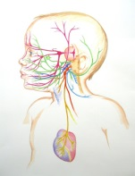
Sponsored by: Fetzik Dentistry

TummyTime!™
Autonomic Nervous System
Regulation & Resilience in the Breastfed Baby
This two-day training is a great addition to anyone’s toolbox
- chiropractor
- baby bodyworker
- midwife, doula
- lactation consultant
- prenatal or baby yoga instructor
- occupational/physical therapist
- speech therapist
- dentist/ENT/Naturopath
- massage therapist
Date: May 2-3, 2015
Site: Holiday Inn Express
10750 Hampton Lakes, Maize, KS

Participants learn:

- Why ANS regulation is vital for a healthy breastfed baby
- The connection to tummy time with healthy ANS regulation
- Learn to teach the TummyTime!™ method
- How to promote optimal ANS regulation to help breastfeeding
- The Social Nervous system function and impact on breastfeeding
- How to talk to parents about challenges, pain and crying
- How to problem solve challenges babies face during tummy time
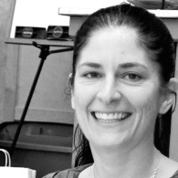
Michelle Emanuel, OTR/L, CST, CIMI, NBCR, RYT200 Michelle has over 18 years of therapeutic pediatric occupational therapy experience, including NICU, outpatient and private practice with an exclusive emphasis on the pre-crawling baby. She specializes in soft tissue manual bodywork for babies with tethered oral tissues and structural asymmetries such as plagiocephaly/torticollis. www.lovetummytime.com www.wholebodyllc.com

Fee:
$297.00 Early Bird through March 22, 2015/After March 23, $385.00
To register mail check to:
Michelle Emanuel 6226 Englewood Ave, Cincinnati, OH 45237
Please call or email with any questions:
emanuelot@yahoo.com513-404-7786

